SQL ASSIGNMENT – 3

UsIng Single Row Functions To Customize The Output

- Display the current date. Label the column Date.

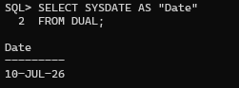
2. Display employee number, last name, salary, and salary increased by 15.5%.

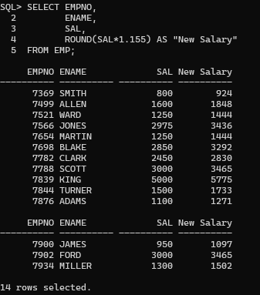

3. Display Increase (New Salary - Old Salary).

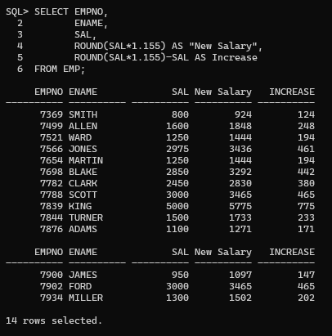

4.Display employee names (InitCap), length of name, names starting with J, A or M.

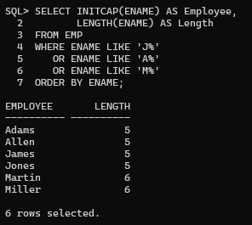

5.Prompt user for first letter of employee name.

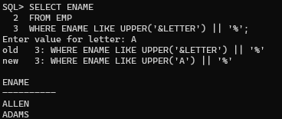
6.Display months worked.

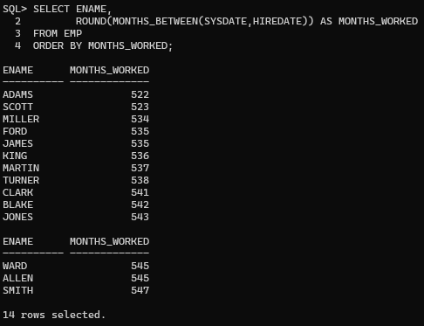

7.Dream Salaries.

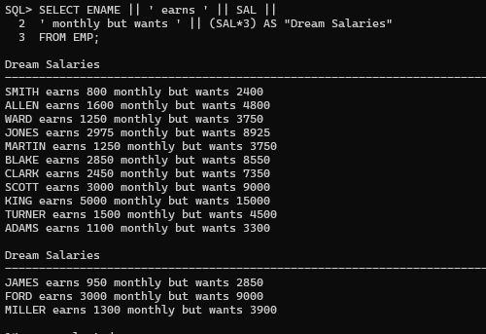

8.Display salary left-padded with $.

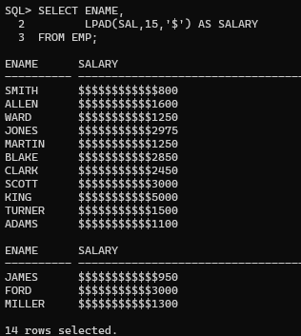

9.Salary Review Date.

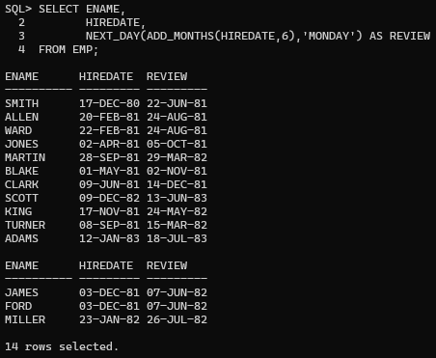

10.Display day employee joined.

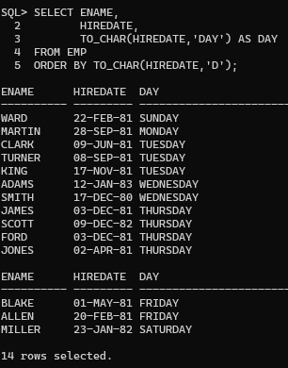

11.Display commission or "No Commission".
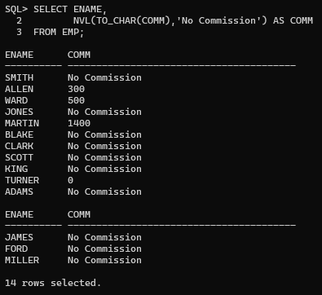

- Display salary with asterisks.

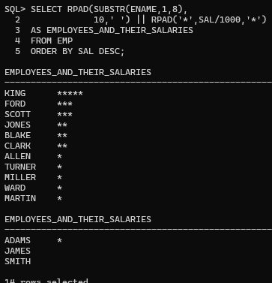

- Using DECODE().
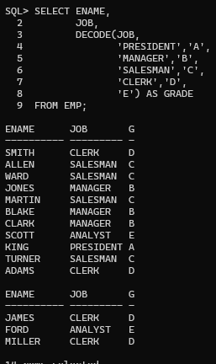
- Using CASE.
